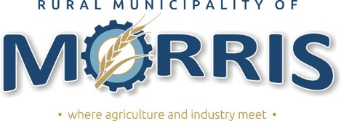

PUBLIC NOTICE IS HEREBY GIVENT THAT the Public Utilities Board of Manitoba has given approval to the following utility rates effective January 1, 2020.
Commodity Rates per one thousand gallons of water
2019 Rates 2020 Rates 2021 Rates 2022 Rates
Urban water consumption $ 17.96 $ 19.01 $ 19.07 $ 19.14
Sewer charge $ 1.75 $ 1.99 $ 2.23 $ 2.47
Urban deficit recovery rate rider $ 3.61 - - -
Rural water consumption $ 10.78 $ 13.00 $ 15.03 $ 17.05
Rural deficit recovery rate rider - - - -
Bulk water consumption $ 23.01 $ 21.00 $ 21.00 $ 22.00
Sewer only charge $ 5.25 $ 38.39 $ 41.03 $ 43.67

Urban quarterly service charge $ 20.00 $ 20.48 $ 20.96 $ 21.44
Rural quarterly service charge $ 27.30 $ 20.48 $ 20.96 $ 21.44
Accounts shall be billed quarterly, and will be due and payable not less than twenty-one days after the date of billing. A late payment charge of 1.25% per month shall be charged on the dollar amount owing after the billing due date.
In the event that an Account remains outstanding the Account will be transferred to the realty tax account of the property in respect to which the water account is unpaid, to be collected as ordinary realty taxes.
For a complete copy of By-Law No. 1732/2018 please visit our website at : rmofmorris.ca

